Absorbed by INTERCOM

In Kropff & Laar (1993), p. 42 we have the absorption of the three kinds of fluxes in the canopy (indexed df, drt, drdr) for the i’th component of the canopy at height j:

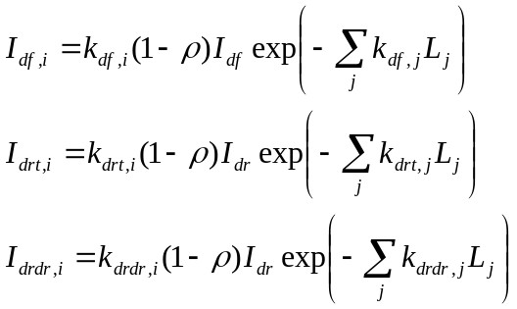 (eqs. 4.15-4.17)

where ρ is the reflected fraction of light.

The absorption of directly sunlit leaf area is calculated later on. Here, we calculate the absorption of the shaded leaf area (=only hit by indirect light). This area gets all the absorption of atmospherically diffuse light (I_{df,i}) plus part of the absorbed direct light namely the total absorption of direct light (I_{drt,i}) minus the part of that which is absorbed directly (I_{drdrf,i}):

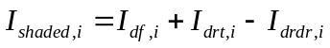 (eq. 4.18)

Hmm, that looks suspect. What keeps I_{shaded,i} from going negative?

The code in Jon’s C++ program (assimilation.cpp, lines 72-102) copies the equations above. Try putting a guard in there to check that I_{shaded,i} is never negative:

if (shdlv > -1e-6 && shdlv < 0)
shdlv = 0;
else
cerr << “Negative absorption for leaves = ” << shdlv;

The if statement allows for numerical inaccuracy the else clause catches model errors.

Does Jon’s program fail this test? Certainly my coding based on Jon’s does.

Back to the sacred FORTRAN scripts then. Look on page 227 in K&L. Oh! The neat term

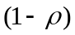

now is used in three different versions depending on the type of light. Equations 4.15-4.17 should really be written like

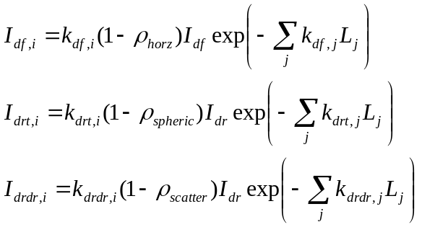

where I renamed the reflection symbols from FORTRAN: REFVH, REFVS and SCV.

It does seem like Jon’s coding is at err and should be corrected.

Niels
29 January 2010.

